Derrick L. Black EDUC 5306
September 26, 2012 Dr. Wilson

This particular tool on Web 2.0 is called Noteflight.com. Anyone can use this website to create original musical compositions and have it scored directly to sheet music. These compositions can either be saved as a private document or it can be shared as a public work and posted to a music community where it can receive feedback from those in the community. as the home page of the website so accurately states, “Noteflight's easy-to-use interface allows younger learners to intuitively interact with notation and musical ideas.” Students can actually experience the various dynamics of musical composition with a “learning by doing” approach. Students create music and musical scores by manipulating various notes, rests, accidentals, and many others.
I see students using this website as a means of creatively composing original music pieces in class as well as at school or anywhere else if they are mobile and own a mobile device. This would be a part of the song writing unit that I do every year after teaching the basic music theory of notation, note names, note values, the musical staff, creating and performing rhythms, and sight-reading. Instead of having students write their rhythmic and melodic ideas out on music manuscript paper, students can explore and experiment with various ideas and actually get a chance to hear what it sounds like before they finalize it. In this way, they can make adjustments to their piece as they go along. Each student can then share and play their original pieces to the rest of the class by uploading them to the public community sight and then letting them listen to it and critique it from there.
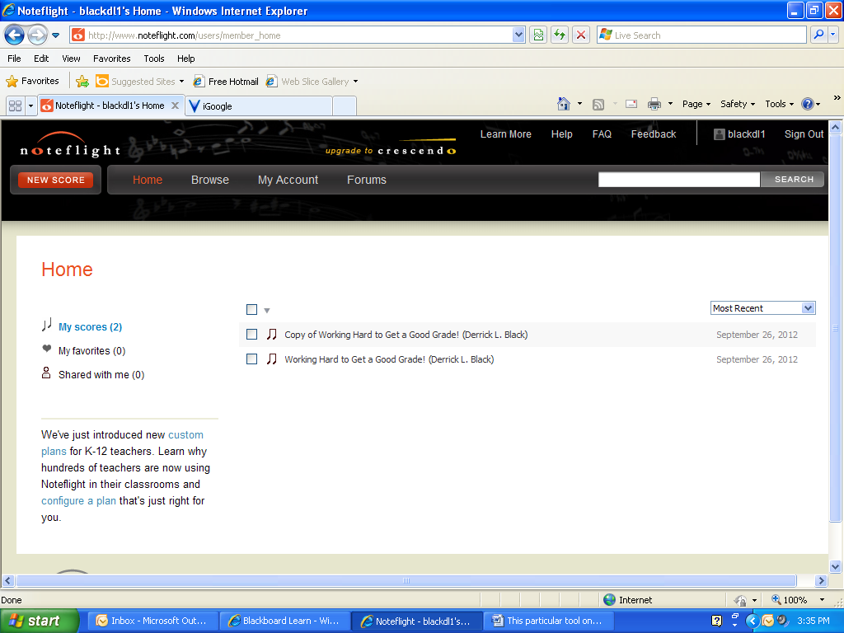
1. Students begin by signing into the Home page of the site and going to red button in far left corner of scene and clicking on “New Score”. This will take you to a blank 4 measure music staff where the students will begin constructing their new music score.

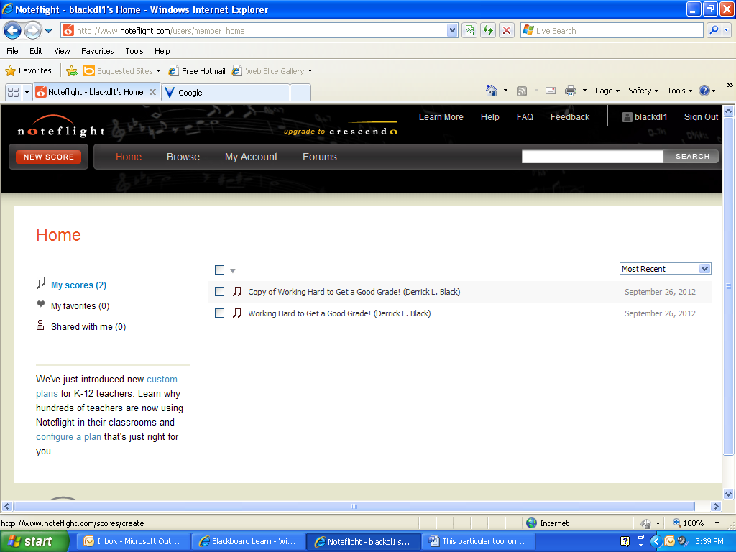
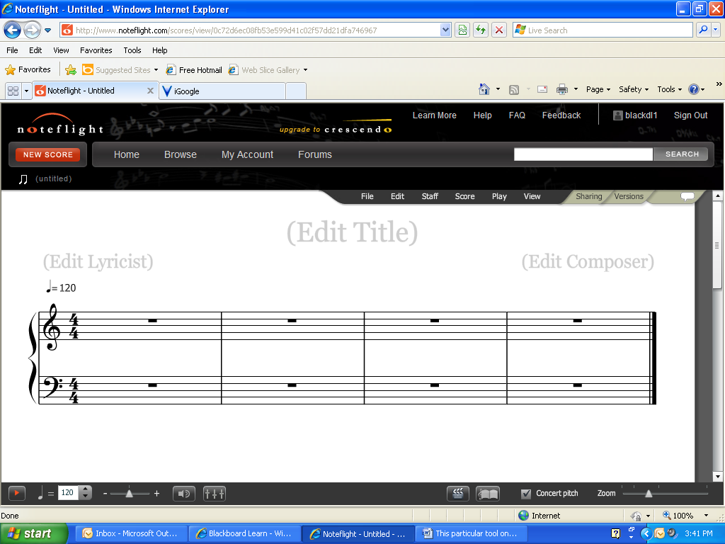

2. Students can now click on a music line on the staff line on the music staff and a note note head will appear. A student student can assign notes of any
Value to any line to create them the melody or harmony of their their choice. They can listen to what ther what their creation sounds like a and make any desired changes.

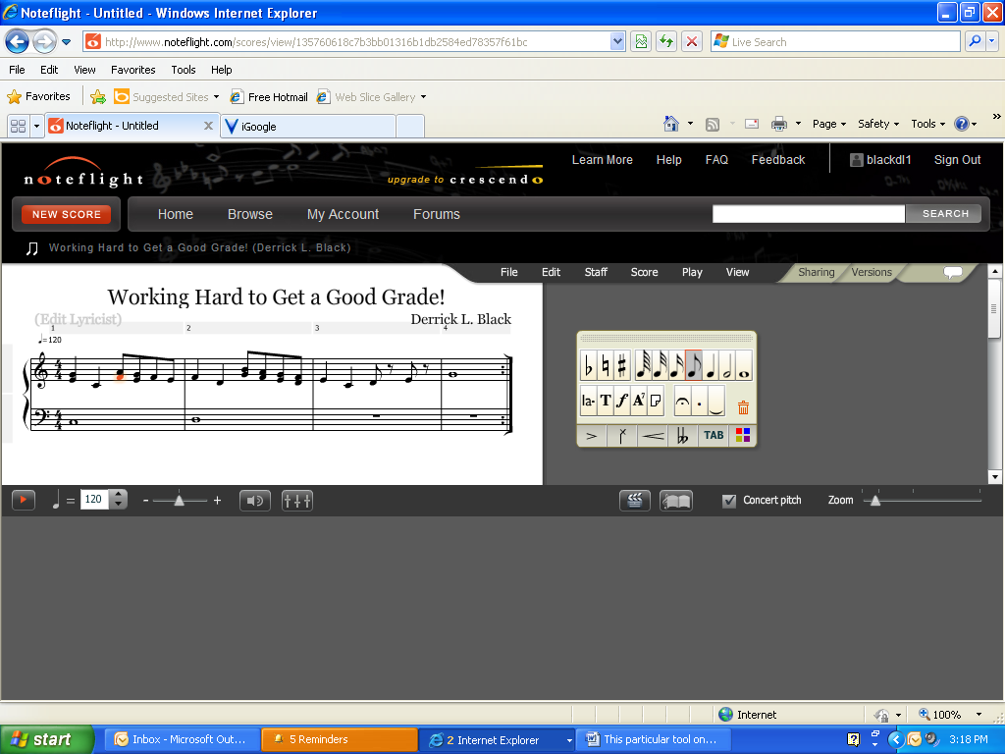
3. Once finished, the student can can title it, save it, and share it with with others on-line.

