Derrick L. Black – Assignment 1 August 28, 2012

[](http://www.google.com/imgres?imgurl=http://www.cbsd.org/schools/unami/teams/sapphire/PublishingImages/basketball.jpg&imgrefurl=http://www.cbsd.org/schools/unami/student/council/Pages/BasketballTournament.aspx&usg=__2nVZjawfITmtWMza7DdT0dodZu0=&h=482&w=318&sz=18&hl=en&start=25&zoom=1&tbnid=7YM_KNOGC8gL5M:&tbnh=129&tbnw=85&ei=g-46UIbvL8Wa2AWZooD4Dg&prev=/search?q=basketball&start=20&hl=en&safe=off&sa=N&gbv=2&tbm=isch&itbs=1)

[](http://www.google.com/imgres?imgurl=http://www.jbpiano.com/uploads/images/Possible%20main%20page%20pictures/piano.jpg&imgrefurl=http://www.jbpiano.com/&usg=__XCVnoT-aU3lS5nL1Ke5J36lmwwg=&h=329&w=500&sz=13&hl=en&start=4&zoom=1&tbnid=w54HdKm3ETN9bM:&tbnh=86&tbnw=130&ei=bOY6UObdHYHL2QXHpoGwCQ&prev=/search?q=piano&hl=en&gbv=2&tbm=isch&itbs=1)[](http://www.google.com/imgres?imgurl=http://ashishpanjabi.files.wordpress.com/2012/07/purple-microphone1.jpg&imgrefurl=http://ashishpanjabi.wordpress.com/2012/07/15/testing-testing-is-this-microphone-on/&usg=__NHuhL3eQ6IH-Z4a7shnPCmEcBOQ=&h=692&w=692&sz=41&hl=en&start=19&zoom=1&tbnid=djapH8sRbCF5GM:&tbnh=139&tbnw=139&ei=tuw6UIaCGsj8rAHt9YGgBQ&prev=/search?q=microphone&hl=en&safe=off&gbv=2&tbm=isch&itbs=1)

[](http://www.google.com/imgres?imgurl=http://wallpaper4god.com/wallpapers/christian-cross_1002_1024x768.jpg&imgrefurl=http://wallpaper4god.com/en/background_christian-cross/&usg=__Z2jZi9Wsb9pyQ81REcihnWI6dXw=&h=768&w=1024&sz=34&hl=en&start=10&zoom=1&tbnid=WYK5NQaDqqRNkM:&tbnh=113&tbnw=150&ei=f-g6UO34NsS3rQHVuYGYDg&prev=/search?q=cross&hl=en&gbv=2&tbm=isch&itbs=1).

Cross

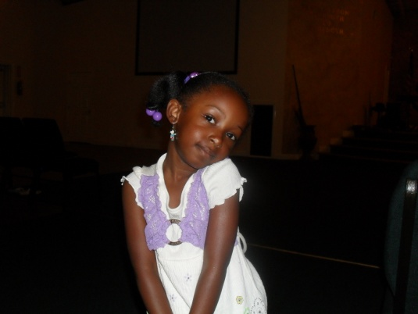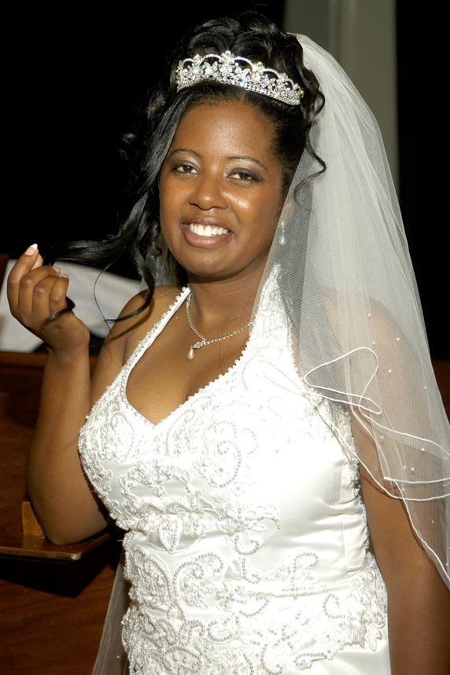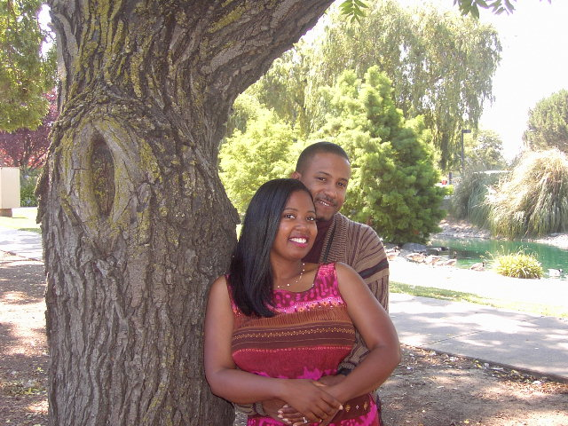[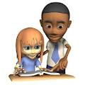](http://www.google.com/imgres?imgurl=http://scm-l3.technorati.com/11/09/10/50949/teacher.gif?t=20110910204904&imgrefurl=http://technorati.com/lifestyle/article/a-teacher-writes-living-epitaphs/&usg=__6HzjIq-0O13prgOmd6Yj99x6SZc=&h=350&w=350&sz=216&hl=en&start=12&zoom=1&tbnid=EbI97cC5h0JqpM:&tbnh=120&tbnw=120&ei=R-o6UNTaNMz0qQHB-YBg&prev=/search?q=teacher&hl=en&gbv=2&tbm=isch&itbs=1)

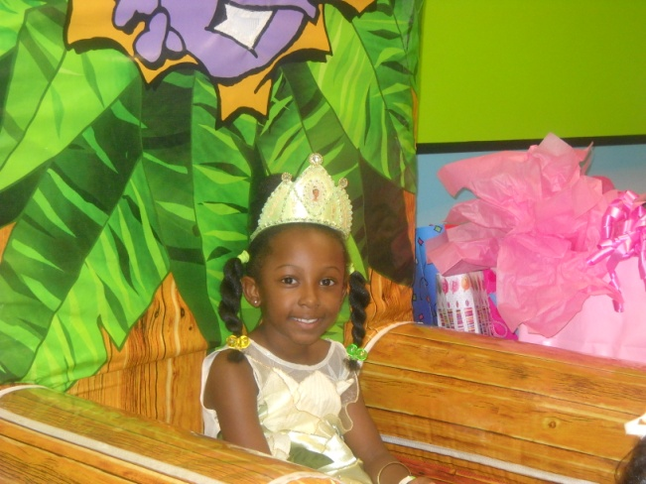

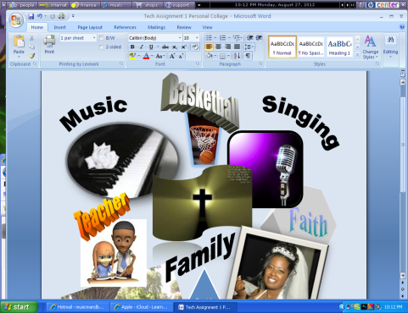



*Live Life…*

*Love Christ!*

+++= The Texas Black Family

|  |  |  |  |  |
| --- | --- | --- | --- | --- |
| Favorite Colors | Favorite Places | Favorite Foods | Favorite Desserts | Fav. Music Artist |
| Black | **San Francisco, CA.** | **Spaghetti** | **Blue Bell Ice Cream** | **Kim Burrell** |
| Purple | **Berkeley Pier, CA.** | **Pizza** | **Sweet Potato Pie** | **Jones Forever** |
| Blue | **San Diego, Ca.** | **Turkey & Dressing** | **Peach Cobbler** | **Justin Savage** |

**Cited Photo Image Web Addresses**

**Piano**

<http://www.google.com/imgres?imgurl=http://www.jbpiano.com/uploads/images/Possible%2520main%2520page%2520pictures/piano.jpg&imgrefurl=http://www.jbpiano.com/&usg=__XCVnoT-aU3lS5nL1Ke5J36lmwwg=&h=329&w=500&sz=13&hl=en&start=4&zoom=1&tbnid=w54HdKm3ETN9bM:&tbnh=86&tbnw=130&ei=I3I8UMzSEKrq2AW9p4HQDA&prev=/search%3Fq%3Dpiano%26hl%3Den%26safe%3Doff%26gbv%3D2%26tbm%3Disch&itbs=1>

**Basketball** <http://www.google.com/imgres?imgurl=http://www.cbsd.org/schools/unami/teams/sapphire/PublishingImages/basketball.jpg&imgrefurl=http://www.cbsd.org/schools/unami/student/council/Pages/BasketballTournament.aspx&usg=__2nVZjawfITmtWMza7DdT0dodZu0=&h=482&w=318&sz=18&hl=en&start=25&zoom=1&tbnid=7YM_KNOGC8gL5M:&tbnh=129&tbnw=85&ei=GXA8UJHrMOf62gWpxoHQDA&prev=/search%3Fq%3Dbasketball%26start%3D20%26hl%3Den%26safe%3Doff%26sa%3DN%26gbv%3D2%26tbm%3Disch&itbs=1>

**Microphone**

<http://www.google.com/imgres?imgurl=http://ashishpanjabi.files.wordpress.com/2012/07/purple-microphone1.jpg&imgrefurl=http://ashishpanjabi.wordpress.com/2012/07/15/testing-testing-is-this-microphone-on/&usg=__NHuhL3eQ6IH-Z4a7shnPCmEcBOQ=&h=692&w=692&sz=41&hl=en&start=19&zoom=1&tbnid=djapH8sRbCF5GM:&tbnh=139&tbnw=139&ei=r3A8UPySJoLu2gWMuIHQDA&prev=/search%3Fq%3Dmicrophone%26hl%3Den%26safe%3Doff%26gbv%3D2%26tbm%3Disch&itbs=1>

**Cross**

<http://www.google.com/imgres?imgurl=http://wallpaper4god.com/wallpapers/christian-cross_1002_1024x768.jpg&imgrefurl=http://wallpaper4god.com/en/background_christian-cross/&usg=__Z2jZi9Wsb9pyQ81REcihnWI6dXw=&h=768&w=1024&sz=34&hl=en&start=10&zoom=1&tbnid=WYK5NQaDqqRNkM:&tbnh=113&tbnw=150&ei=-HA8UOn1Auru2gXV-YDQDA&prev=/search%3Fq%3Dcross%26hl%3Den%26safe%3Doff%26gbv%3D2%26tbm%3Disch&itbs=1>

**Teacher**

<http://www.google.com/imgres?imgurl=http://scm-l3.technorati.com/11/09/10/50949/teacher.gif%3Ft%3D20110910204904&imgrefurl=http://technorati.com/lifestyle/article/a-teacher-writes-living-epitaphs/&usg=__6HzjIq-0O13prgOmd6Yj99x6SZc=&h=350&w=350&sz=216&hl=en&start=12&zoom=1&tbnid=EbI97cC5h0JqpM:&tbnh=120&tbnw=120&ei=tHE8UMulKIjm2QWojIDQDA&prev=/search%3Fq%3Dteacher%26hl%3Den%26safe%3Doff%26gbv%3D2%26tbm%3Disch&itbs=1>

**Work Out In Word 2007**

**Techniques Used in Collage**

10. The Insert object Equation Editor was used to type the family equation in the collage. I chose Insert – Object and selected the Microsoft Equation 3.0 to construct my fraction equation. I moved the equation down towards the bottom of the project by clicking on the tab on the right of the equation to change to inline, thus allowing me to move it anywhere on the page.

9. & 8. I selected pictures from two sources: My Pictures Folder & the Internet (Google Images). The images from Google, I right clicked, copied, and pasted onto the collage; copying and pasting the entire address and citing the resource on page two of the assignment so not to clutter the collage with unnecessary words and “busyness”! I also copied and pasted the images from My Pictures files on my computer. I experimented with various shades, shapes, borders, and effects on the images by using the Picture Tool Bar. It really seemed like the design possibilities were limitless! I had to be careful not to spend too much time on one image so that I could actually finish the assignment in a timely fashion!

7. I inserted various WordArt designs. The titles “Music”, “Basketball”, “Singing”, “Teacher”, “Faith”, and “Family” were all created using WordArt. I tilted the words at different angles to give the design a creative touch.

6. I selected two different shapes from the Shapes menu; the triangle and the hexagon. I typed the names of my family members in the triangle and 3D’d the hexagon and pulled the text “Faith” over the face of it. I also rotated the shape to enhance the 3D element.

5. I took a screen shot of my computer screen and pasted it onto the bottom of the collage. I minimized and cropped the screen shot by using the crop tools from the **Picture Tools** selection. I also changed the color of the screen shot.

4. I inserted a header (My Personal Snap-shot Collage!) and page numbers by using the **Insert menu** and clicking on Header and Page Number. I experimented with using various bullets within my table but ultimately decided against using them in the final design because of the extra space used when implementing the bullets option.

I changed the Hyperlink color by selecting the **Home menu**, then selecting the drop down menu for **Styles and** clicking on **Hyperlink.** Here, I had the option of changing the color of the **hyperlink.**

Finally from this section, I created a page border by clicking on **Page Layout** menu and selecting **Page Borders**; choosing the border that I liked the most.

3. Near the bottom of the collage, I grouped a scroll shape with a text box that contained the words “Live Life..Love Christ!” by following the prompts found in section 3 of the directions. I chose the scroll shape and created a text box and wrote in it “ Live Life, Love Christ!” I held down the shift key and clicked on each image. Still holding the shift key down, I right clicked and highlighted “Group”, causing the two images to join as one for moving.

I inserted a table by choosing Insert and deciding to use five columns and four rows. I selected a table design that contained shading and changed the borders of the table. I choose not to merge cells because I wanted them to be separate cells.

2. The blue “water” background at the bottom of the collage was achieved by implementing the ClipArt function on Office Online. I copied and pasted the design directly from Office Online. I minimized, cropped, and Text Wrapped it behind the text, giving a nice backdrop to the overall collage design.

1. The acquisition of images from Google is exactly what I did for step nine in the lesson. I documented the sources on page two of this assignment.