“Instrument Family Reunion”
Lesson Plan

Mr. Black 3rd Grade: Two 45
Music minute classes

Objectives 1. Learner will identify and name specific instruments.
2. Learner will group instruments according to instrument family relationship.
3. Learner will graph the number of instruments found in each instrument family to determine which family has the most instruments.

TEKS-, 1.2A, 1.3B, & 1.4A

Materials - 15 small buckets filled with cut-out pictures of various instruments
- Paper with names of all four instrument families on them
- Pencil
- Computers with access to Excel program (Computer Lab)
- Instrument Family Posters

Procedures Day 1
1. Start lesson by asking students to review and name the four instrument families known in music. (Brass, Woodwind, String, and Percussion)
2. Ask students to give one example of an instrument from each instrument family. These instruments will be written on the board under which ever family it belongs to.
3. Explain to students that they will be placed in partner groups and each group given a bucket filled with pictures of random instruments. Students in each partner group will also be given a sheet of paper with all of the instrument family names listed and a pencil.
4. Each student in a group will take turns pulling a picture out of the bucket; identifying its name and placing the picture under the correct listed instrument family name. Student will also record and write the name of the instrument under that category. The other student will then take his/her turn and proceed to do the same thing as the first student; drawing a picture of an instrument from the bucket, identifying its name, correctly categorizing it under the instrument family it belongs to, and then writing the name of the instrument below its listed family name. The group will continue to draw pictures out of the bucket, taking turns, until they have drawn and listed 20 instruments.
5. They will evaluate their data and count how many instruments they have in each instrument family and write that total next to each instrument family name.
6. Students will then have an opportunity to share their data with the rest of the class; sharing how many instruments each family has from their group.
7. Students will return pictures to buckets, return buckets to cabinets, return pencils to pencil cups, and turn in papers with their written instrument family data on it.

Day 2
1. Class will meet in school computer lab. Students will partner and given data sheets from previous activity.
2. Teacher will demonstrate how to use Excel to first list instrument families and show data of how many instruments were identified in each family. Teacher will then demonstrate how to transfer data into a graph format.

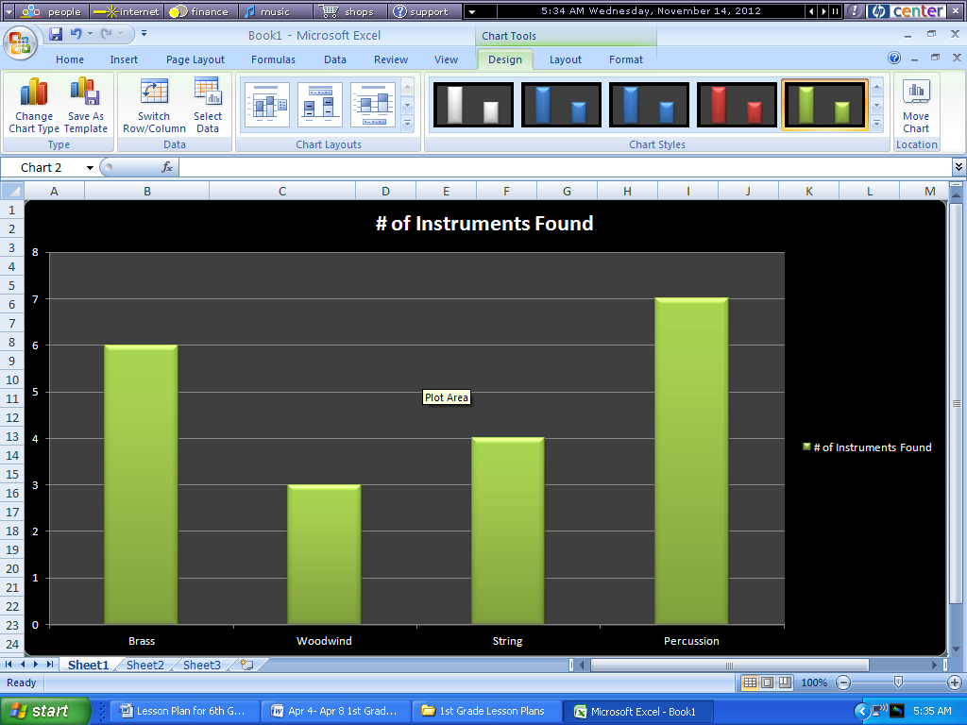

* Type in data on spreadsheet. * Click on any used box in spreadsheet, then
“Insert”, and then any style under “Charts”.

3. After watching teacher demonstration, students will insert their
data onto the spreadsheet and then graph their data. They can then
experiment with graph design, style, and color choices.
4. Students will print out their completed graphs, discuss and show
their graphs to the rest of the class, and then turn in.

Evaluation - Observational – For Day 1, students will be assessed by observing the groups working on the categorizing of the music instruments. Also, a rubric will be used. A high score of 10 will be given if all instruments have been correctly identified and placed in the correct family. A score of “9” will be given if one or two instruments have been misidentified and not placed in the correct family. An “8” will be assigned if 3 or 4 instruments are misidentified and/or misplaced in the family categories. A”7” given signifies a misidentification of 5-6 instrument names and/or misplacement of instrument in family. A “6” means 7 or 8 instruments misidentified and/or misplaced in instrument family. A “5” means 9-10 misidentified, “4” means 11-12 misidentified, and so on.
- Day 2 will be assessed by how well each group follows the directions given by the teacher. A “5” score will be given if all data is included and represented by the graph. A “4” score given if 1 or 2 components are missing from data or graph...a “3” score given if 3 or 4 pieces of data are missing from assignment.

